SIMATS ENGINEERING
NAME: A.Preetika Sudhakar
RREG NO. 192371073
COURSE NAME: Database Management Systems
COURSE CODE: CSA0501
4. DML Commands with Constraints (UPDATE, DELETE)

To perform Data Manipulation Language (DML) Commands such as UPDATE, DELETE in the table. Description:
Data Manipulation Language (DML) statements are used for managing data within schema objects. DML Commands: Update, Delete
➢ UPDATE - updates existing data within a table
➢ DELETE - deletes all records from a table, the space for the records remain

UPDATE:
UPDATE table_name
SET column1=value, column2=value2,...
WHERE some_column=some_value;
DELETE:
DELETE FROM table_name
WHERE some_column=some_value;
Questions:
1. Update the value
2. Delete the record
3. Modify the age
4. Remove all

OUTPUTS:

1) Update the owner name whose owner_id is 1
UPDATE owners SET owner_name = 'Arun Prakash' WHERE owner_id = 1;
Check:
SELECT * FROM owners;
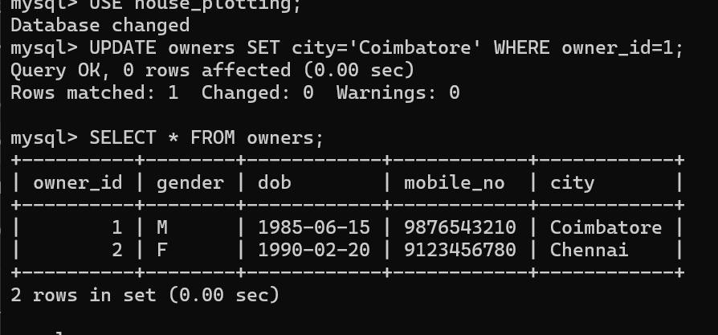
2. Delete owner with id 3:
DELETE FROM owners WHERE owner_id=3;
Check:
SELECT * FROM owners;
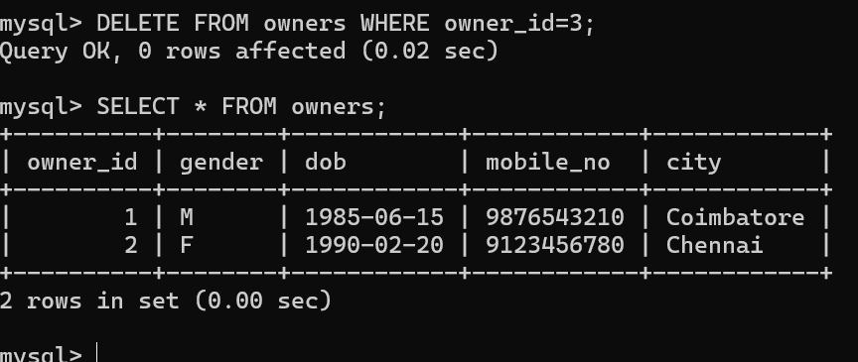
3. UPDATE plots
UPDATE plots SET price=1900000.00 WHERE plot_no='P102';
Check:
SELECT * FROM plots;

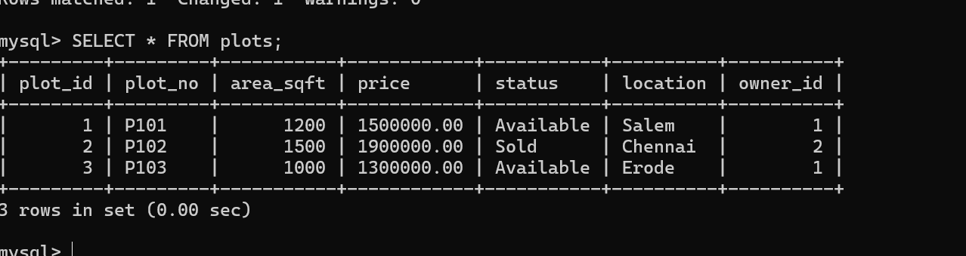

4. DELETE plots
DELETE FROM plots WHERE area_sqft > 1400;
Check:
SELECT * FROM plots;
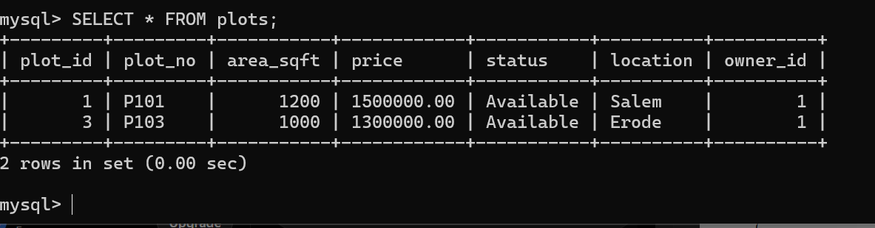
RESULT:
Data Manipulation Language (DML) Commands such as UPDATE, DELETE are performed in the five tables.

